# **Nebraska 2024-2025**

3.1.2025-15.1.2025 – 12 days

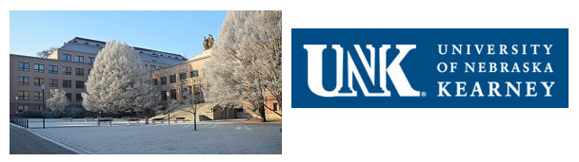

|  |  |  |  |
| --- | --- | --- | --- |
| …./ 12 2024 |  | **online meeting** | … am US = … pm CR |
| 3/1 2025 | Friday | arrival in the Czech Republic |  |
| 4-5/1 | Saturday - Sunday | Free time in Prague |  |
| 6/1 | Monday | administration, orientation day |  |
| 7-10/1 | Tuesday-Friday | Meeting, teaching, hospital, excursion |  |
| 11-12/1 | Saturday - Sunday | Vienna |  |
| 13/1 | Monday | teaching, hospital, excursion, **Farewell** |  |
| 14/1 | Tuesday | Prague |  |
| 15/1 | Wednesday | departure | - flight |

|  |  |  |  |
| --- | --- | --- | --- |
| 7/1  Tuesday | Welcome, excursion in university hospital  Nursing theory  M.Sc. Petra Kašparová, Ph.D.  (students will prepare and deliver their presentations) | 3 hours  4 hours |  |
| 8/1  Wednesday | Internship in university hospital | 8 hours |  |
| 9/1  Thursday | Physiotherapy  M.Sc. Petra Gaul Aláčová, Ph.D. (comfortable clothes for exercise)  Excursion in university hospital | 4 hours  3 hours |  |
| 10/1  Friday | Internship in university hospital | 8 hours |  |
| 13/1  Monday | ŠUMPERK - hospital visit  Olomouc - **Farewell** | 8 hours |  |