**SKILARENCE tbl – CEA analýza**

Srovnání LP SKILARENCE a komparátorů pro 1. linii syst. léčby u pacientů, kteří již podstoupili lokální léčbu a fototerapii:

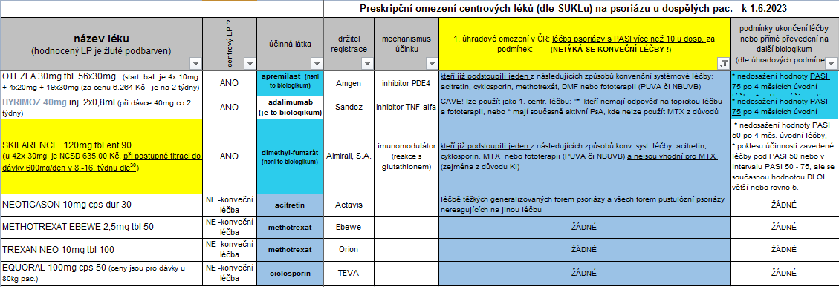

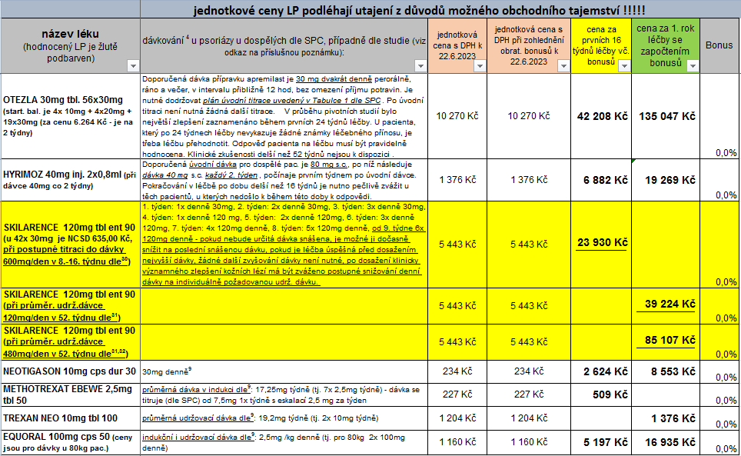

**Závěr CEA analýzy: LP SKILARENCE vychází (viz grafy níže) po indukční době 16-ti týdnů, i po 1. roce léčby, ze všech intervencí 1. linie systémové léčby jako předposlední, jen před LP OTEZLA. Ani při srovnání u pacientů s různými komorbiditami (viz níže) nepřináší nějakou významnou výhodu. Aby byl LP SKILARENCE cca na cost/effect úrovni LP NEOTIGASON či HYRIMOZ (u pac. nevhodného k methotrexátu dle znění úhradových podmínek) musel by být při aktuálních cenách bonus kolem 80 % !**

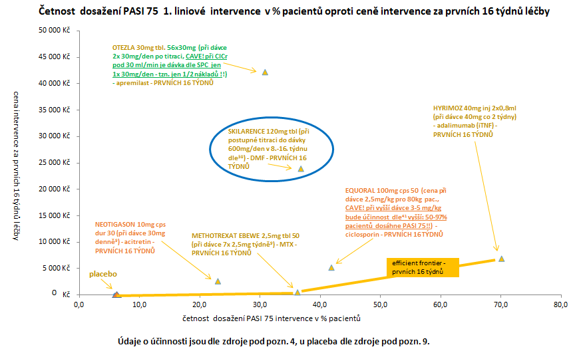

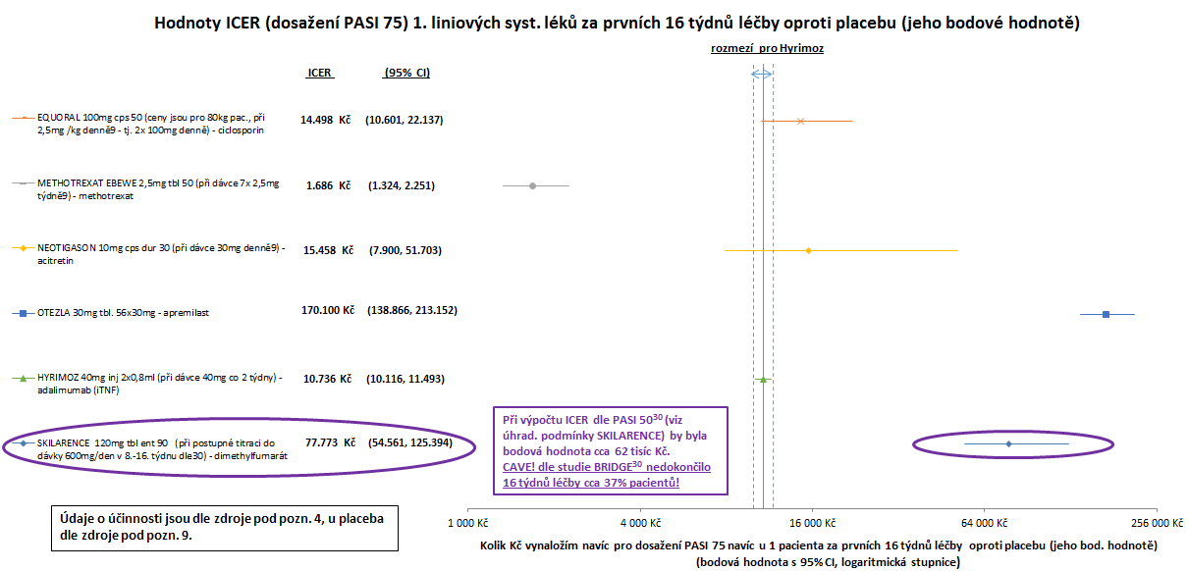

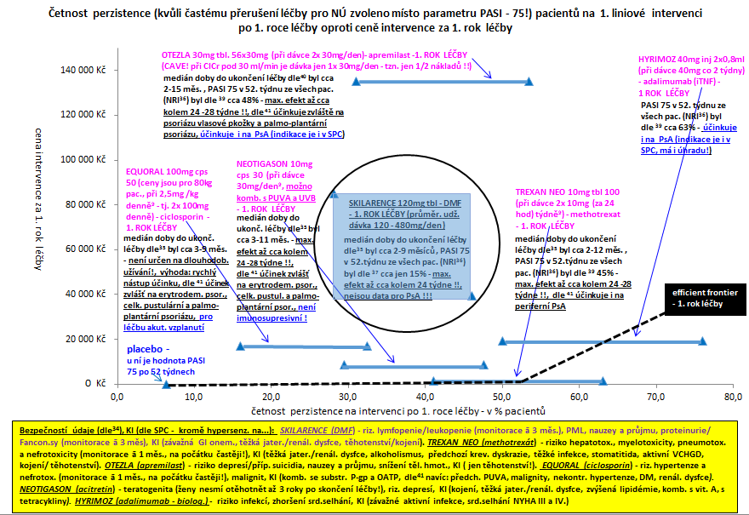

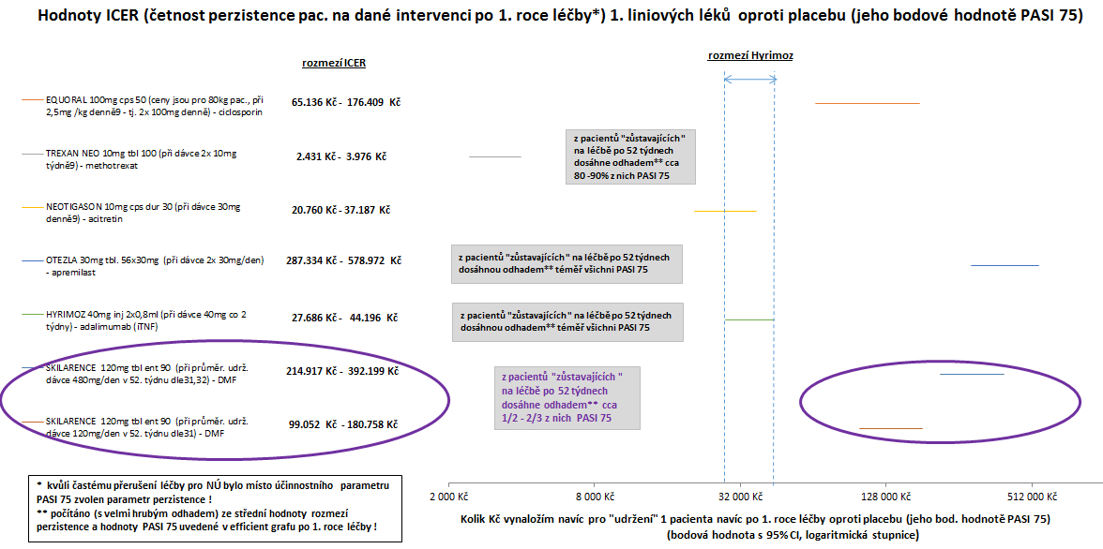

Srovnání LP SKILARENCE a komparátorů pro 1. linii syst. léčby u pacientů s komorbiditami:

(upraveno dle zdroje uvedeného níže pod pozn. 45, autorem této CEA analýzy byl zvýrazněn hodnocený LP)

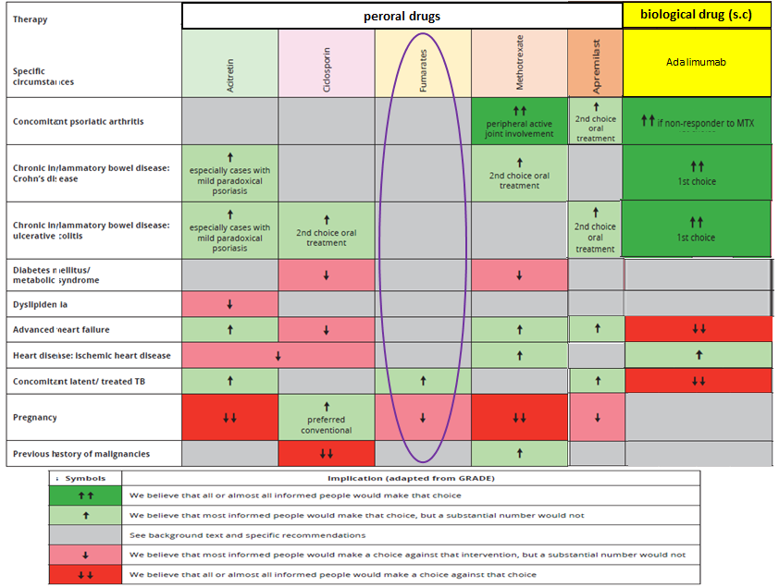

Zpracoval: Mgr. Jaroslav Duda 23. 6. 2023

Poznámky a literatura:

4. Armstrong A, et al. Efficacy of Bimekizumab and Other Biologics in Moderate to Severe Plaque Psoriasis: A Systematic Literature Review and a Network Meta-Analysis. Dermatol Ther (Heidelb) (2022) 12:1777–1792

9. Strukturované podání HUMIRA, systémová léčba psoriázy od AbbVie z 18.3.2020 - ze spisu zn. SUKLS237340/2020 k HUMIRA z www.sukl.cz

30. Mrowietz U, et al. Efficacy and safety of LAS41008 (dimethyl fumarate) in adults with moderate-to-severe chronic plaque psoriasis: a randomized, double-blind, Fumaderm®- and placebo-controlled trial (BRIDGE). British Journal of Dermatology (2017) 176: 615–623

31. Augustin M, et al. Long-Term Treatment with Dimethyl Fumarate for Plaque Psoriasis in Routine Practice: Good Overall Effectiveness and Positive Effect on Impactful Areas. Dermatol Ther (Heidelb) (2022) 12:1121–1131

32. Pellacani G, et al. Efficacy and Safety of Dimethyl Fumarate in Patients with Moderate-to-Severe Plaque Psoriasis: DIMESKIN-2, a Multicentre Single-Arm Phase IIIb Study. J. Clin. Med. 2022, 11, 4778. https://doi.org/10.3390/jcm11164778

33. Daudén E, et al. Efficacy and Safety of Dimethyl Fumarate in Patients with Moderate-to-Severe Plaque Psoriasis: Results from a 52-Week Open-Label Phase IV Clinical Trial (DIMESKIN 1). Dermatol Ther (Heidelb) (2023) 13:329–345

34. Balak DMW, et al. Long-term Safety of Oral Systemic Therapies for Psoriasis: A Comprehensive Review of the Literature. Dermatol Ther (Heidelb) (2020) 10:589–613

35. Alabas OA, et al. Effectiveness and persistence of acitretin, ciclosporin, fumaric acid esters and methotrexate for patients with moderate-to-severe psoriasis: a cohort study from BADBIR. Br J Dermatol 2023; 188:618–627

36. NRI = tzv. "non-response imutation" přístup kalkulace celkové účinnosti.

37. Gnesotto L, et al. Dimethyl Fumarate Treatment in Patients with Moderate-to-Severe Psoriasis: A 52-week Real-life Study. Acta Derm Venereol 2023; 103: adv4526. DOI: 10.2340/actadv.v103.4526

38. Sbidian E, et al. Persistence of apremilast in moderate-to-severe psoriasis: a real-world analysisof 14 147 apremilast- and methotrexate-naive patients in the French NationalHealth Insurance database. Br J Dermatol 2020; 182 (3): 690-697

39. Armstrong A, et al. Indirect comparison of the short-, mid-, and long-term efficacy of treatments for moderate to severe plaque psoriasis: a systematic review and network meta-analysis - presented at the Fall Clinical Dermatology Conference; October 20–23, 2022; Las Vegas, NV

40. Sotiriou E, et al. Apremilast Survival and Reasons for Discontinuation in Psoriasis: Five-Year Experience From a Greek Tertiary Care Centre. Dermatol Pract Concept. 2022;12(2):e2022076. DOI: https://doi.org/10.5826/dpc.1202a76.

41. Menter A, et al. Joint American Academy of Dermatology - National psoriasis Foundation guidelines of care for the management of psoriasis with systemic nonbiologic therapies. J Am Acad Dermatol. 2020, 82: 1145-1486.

42. Mason KJ, et al. Persistence and effectiveness of nonbiologic systemic therapies for moderate-to-severe psoriasis in adults: a systematic review. Br J Dermatol. 2019, 181: 256-264.

43. Piragine E, et al. Adherence and Persistence to Biological Drugs for Psoriasis: Systematic Review with Meta-Analysis. J. Clin. Med. 2022, 11, 1506. https://doi.org/10.3390/jcm11061506.

44. Yiu ZZN, et al. Drug Survival Associated With Effectiveness and Safety of Treatment With Guselkumab, Ixekizumab, Secukinumab, Ustekinumab, and Adalimumab in Patients With Psoriasis. JAMA Dermatol. 2022;158(10):1131-1141.

45. Gisondi P, et al. Italian adaptation of EuroGuiDerm guideline on the systemic treatment of chronic plaque psoriasis. Italian Journal of Dermatology and Venereology 2022 February;157 (Suppl. 1 to No. 1): 1-78.